42.37: a) Pr. (44.36) yields 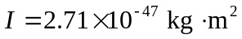, and so 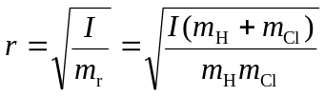
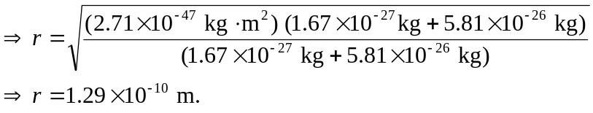
b) From 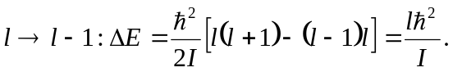 But 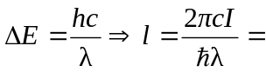
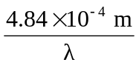. So the l-values that lead to the wavelength of Pr. (44-32) are:
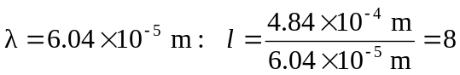.
Similarly for:
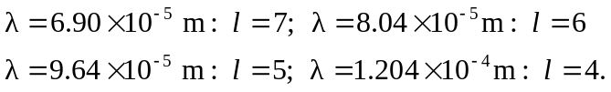
c) The longest wavelength means the least transition energy 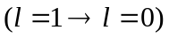
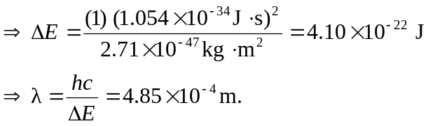
d) If the hydrogen atom is replaced by deuterium, then the reduced mass changes to 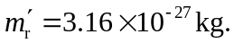 Now,

